**Module-2: GIT Assignment - 5**

You have been asked to:

● Create a gitflow workflow architecture on git

● Create all the required branches

● Starting from the feature branch, push the branch to the master, following the

architecture

● Push a urgent.txt on master using hotfix hotfix branch urgent.txt

**Master branch master.txt f1.txt f2.txt**

Develop/test branch f1.txt f2.txt

F2 branch f2.txt

**F1 branch f1.txt**

On master branch

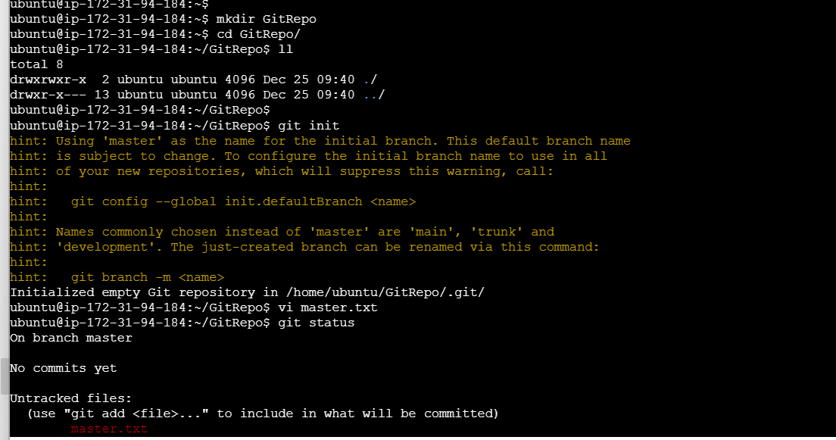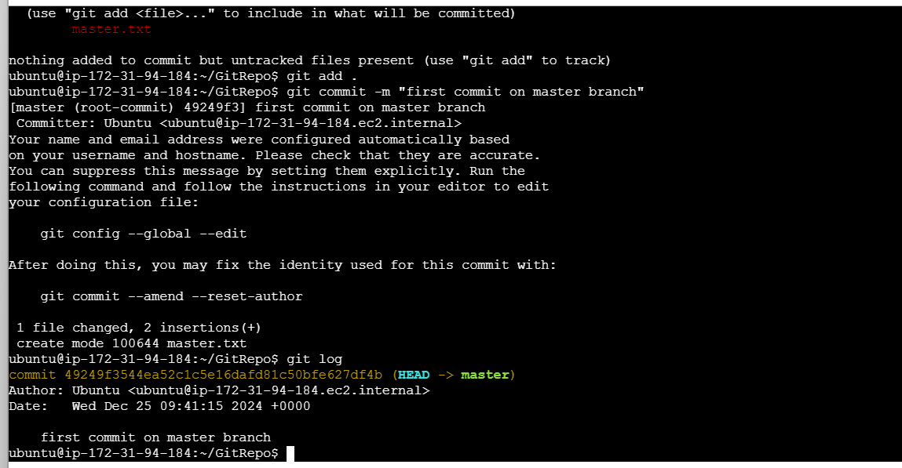

Create f1 branch

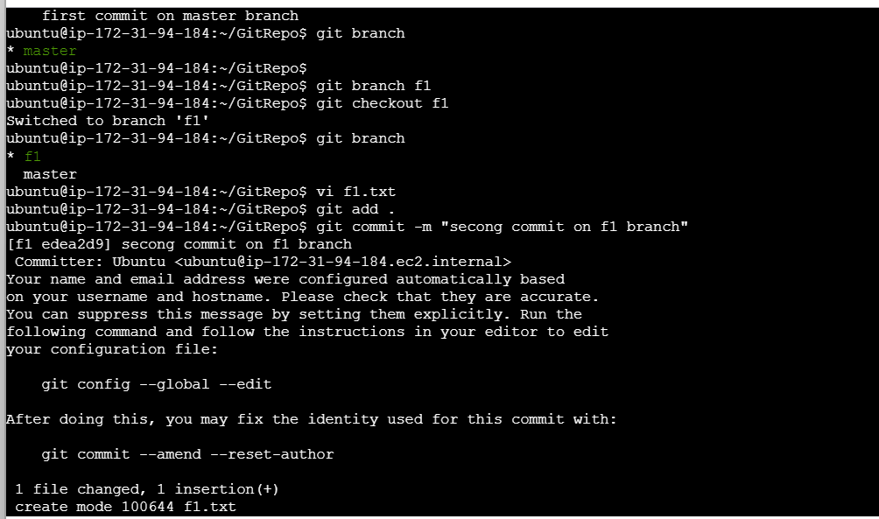

Create f2 branch

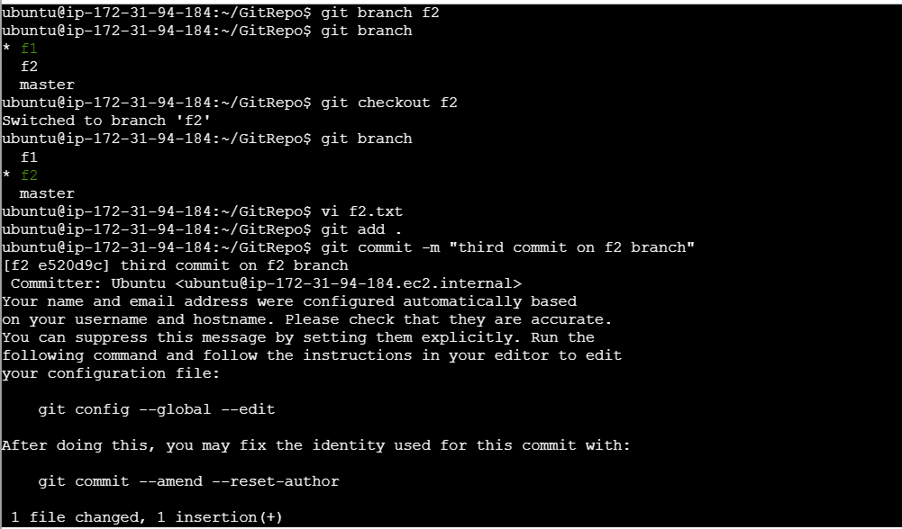

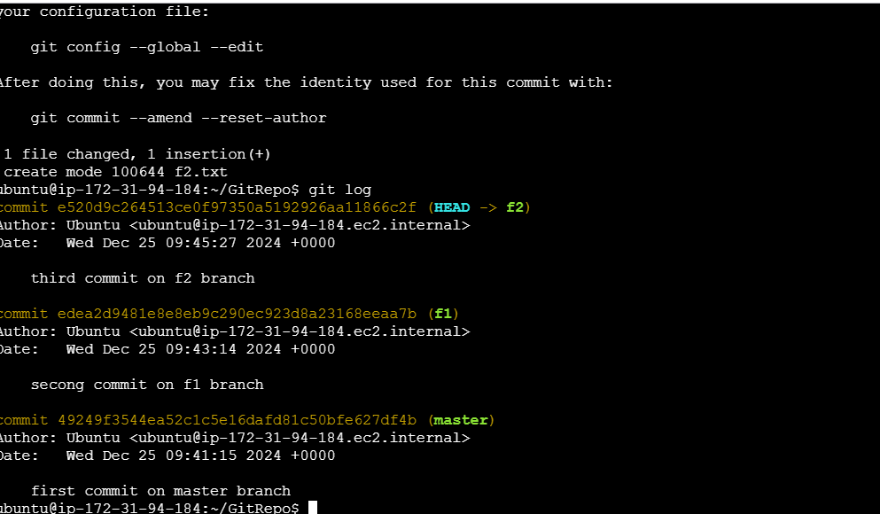

Create develop branch and merge f1 and f2

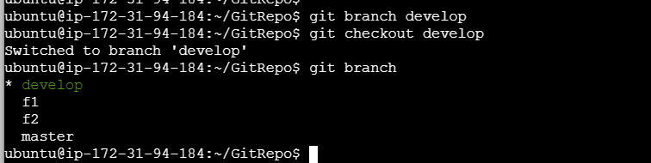

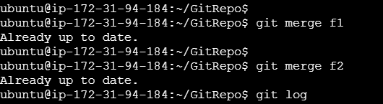

All changes are updated on master branch

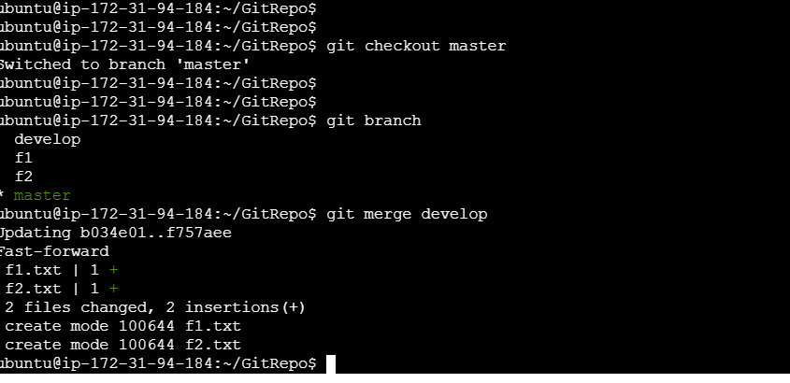

Create hotfix branch and commit urgent.txt after that merge it to the master branch

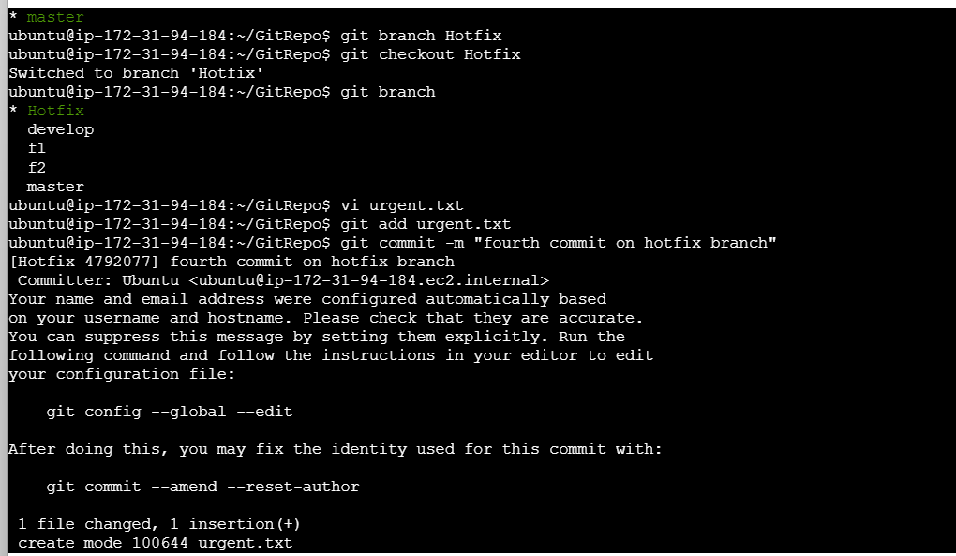

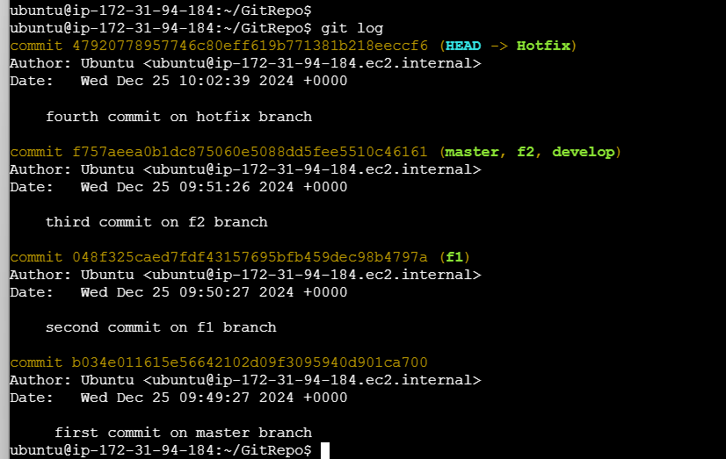

Merge on master

